**GAMIT Matlab Code – version 1.1 (19 Jan 2014)**

**Caspar Addyman**

**Birkbeck, University of London**

[**c.addyman@bbk.ac.uk**](mailto:c.addyman@bbk.ac.uk)

**GAMIT.m**

timeEstimates = **GAMIT**(targetTimes, cognitiveLoad, prospectiveFlag, reproduceFlag, params, referenceCurve, referenceDeltas)

This is the main function to call the GAMIT model it generates a set of retrospective or prospective timeEstimates for a give vector of targetIntervals with or without cognitive load. Can optionally pass set of model parameters and lifetime reference curves.

Example

%50 estimates for t=600

targetTimes = 600 * ones(1,50);

%retrospective

timeEstimates = GAMIT(targetTimes, 1.0, false)

%prospective

timeEstimates = GAMIT(targetTimes, 1.0, true)

**GAMIT_Params.m**

myparams = **GAMIT_Params**(matfile)

Generates or loads a set of parameters used by the model.

%default params

myparams = **GAMIT_Params**();

%loads params from a saved binary file.

myparams = **GAMIT_Params**(‘savedParams.mat’)

**GAMIT_Spreading_Activation.m**

[TotalActivation, AllCurves] = **GAMIT_Spreading_Activation(params, showGraphics)**

Generates an single activation decay curve for the GAMIT model. Can optionally display visualisations of the activation across columns and as a total activation function.

Example

%generate and show a GAMIT curves

**GAMIT_Spreading_Activation (GAMIT_Params,true);**

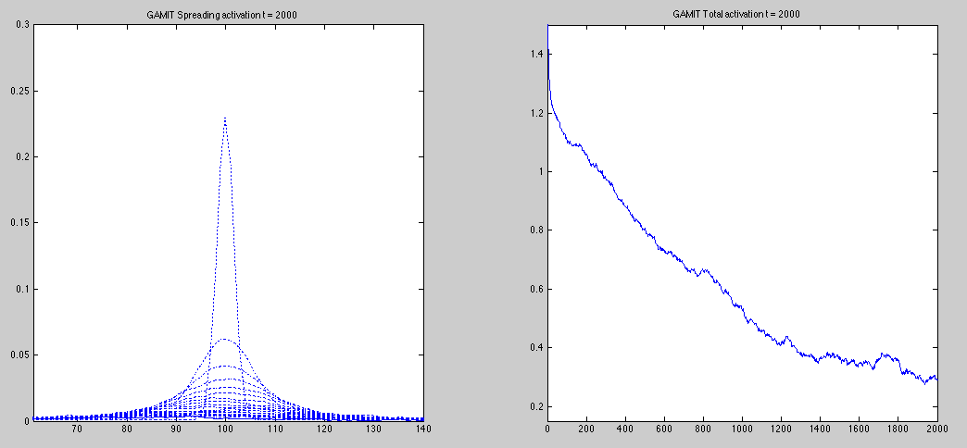

**GAMIT_Lifetime.m**

[lifetimeReferenceCurve, lifetimeDeltaCurve] = **GAMIT_Lifetime**(params, N, showGraphics)

Generates an average lifetime activation decay curve for the GAMIT model and an associated delta curve for prospective timing. Can optionally display visualisations of these.

Example

%generate and show default lifetime curves

**GAMIT_Lifetime(GAMIT_Params,50,true);**

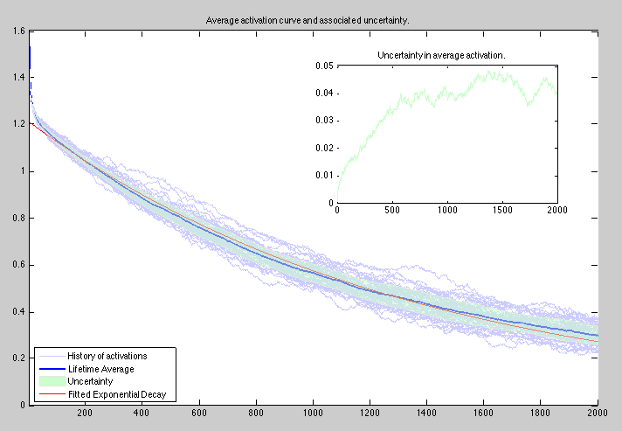

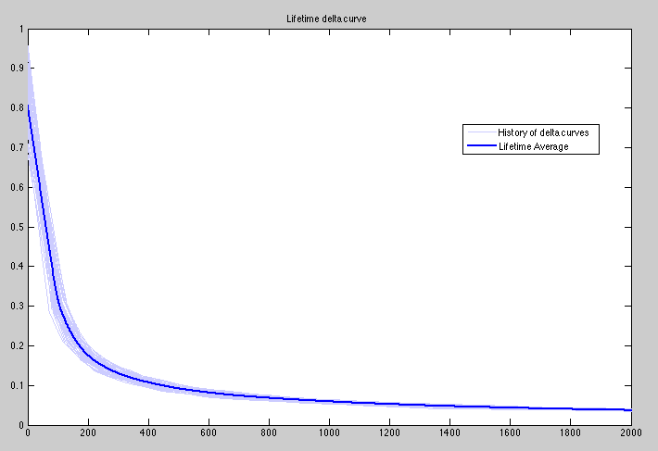

**GAMIT_Weber_Demo.m**

**GAMIT_Weber_Demo**(targetTime, nSamples, prospectiveFlag,method)

Shows the relative error in the GAMIT model for targetTime and set of comparison intervals.

method = 0 compares targetTime and 1.5*targetTime plotting histograms of actual and scaled relative estimates.

method = 1 plots graph of array of 10 targetTimes between 0.2 and 2.0 times the targetInterval together with associated 1sd error bars. These errors are also replotted

Examples

%histogram of retrospective interval estimates for t =600 & t= 900;

GAMIT_Weber_Demo(600,200,false,0);

GAMIT_Weber_Demo(600,200,false,0);

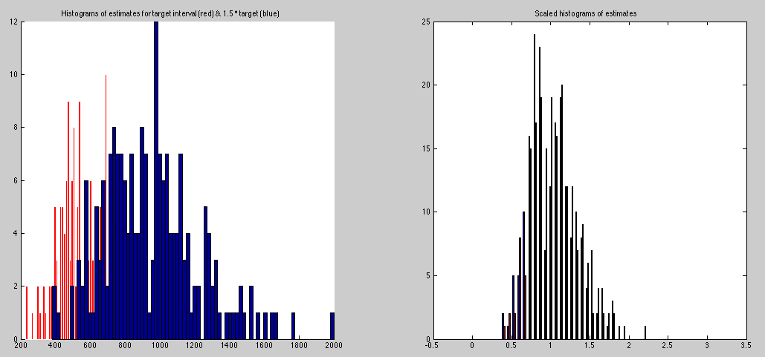

%error bars and relative errors for retrospective interval estimates in a range around t = 600 [120, 240, 360, 480, 600, 720, 840, 960, 1080, 1200]

GAMIT_Weber_Demo(600,100,false,1);

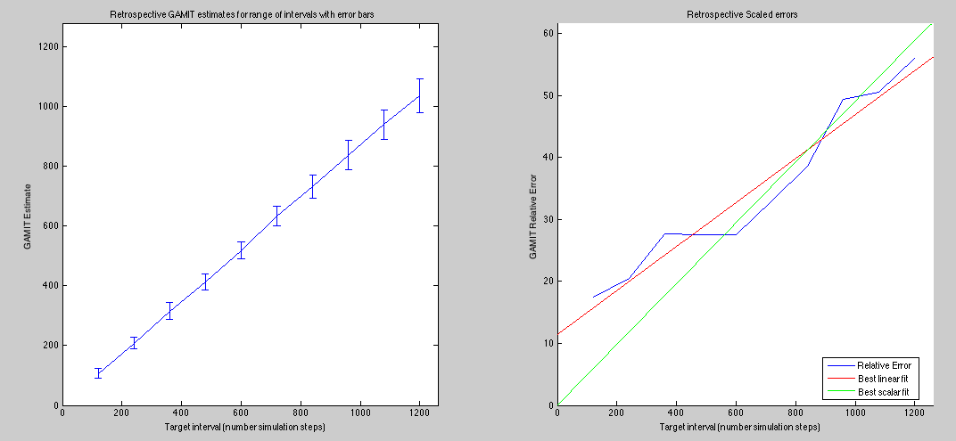

**GAMIT_Retro_Pro_Interaction.m**

**GAMIT_Retro_Pro_Interaction**(targetTime,nSamples,cognitiveLoad,showGraphics)

Shows the relative estimates in the GAMIT model for targetTime with and without cognitiveLoad for retrospective and prospective timing.

Example

%default example shows cognitive load of 1.0 vs 1.2

GAMIT_Retro_Pro_Interaction;

